**Machine Learning Eportttfolioo Content**

Keep Everything the same as my friend copy paste it and change the below only:

And don’t forget to copy all the learning outcomes the same as my friend

Unit 1: introduction to machine learning

Collaborative Discussion 1:

Initial post:

Unit 2: Exploratory Data Analysis

Collaborative Discussion 1:

Peer Response to Fatima Mohammed:

Peer Response to Abdulla Almessabi:

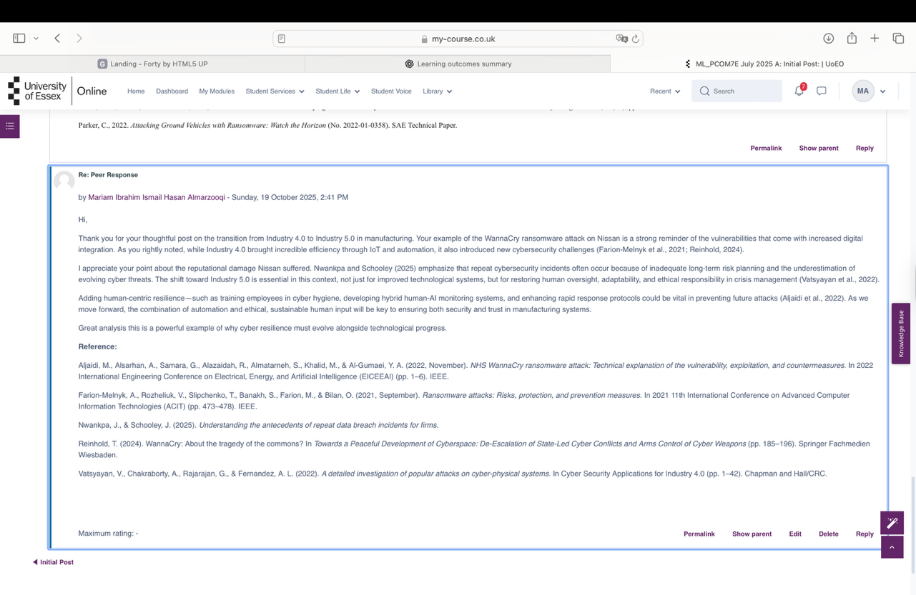

Peer response from Colleagues:

Unit 3: Correlation and Regression

Collaborative Discussion 1:

Summary Post:

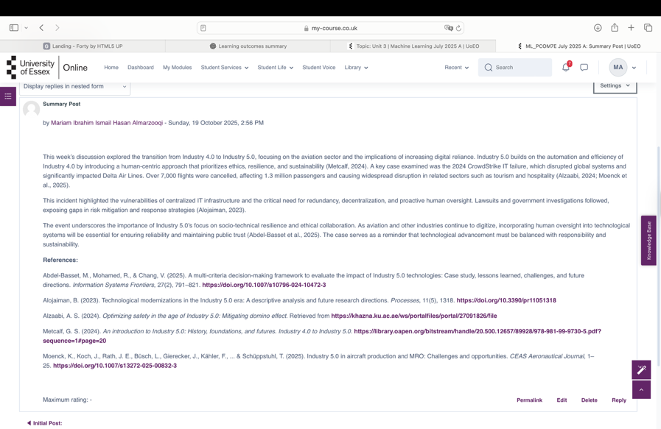

For Eportfolio Activity check if the below is the same as my friend question and answers copy paste her work into my website if not change the answers based on the below



Unit 4: Linear Regression with Scikit_Learn

Team Project Colleagues:

Team Contract:

Attach Group 2- team contract pdf that I sent you

Unit 5: Clustering

E_portfolio Activity:

Check my friend answers in the website if it’s the same question as the screenshot attach the same answer as my friend

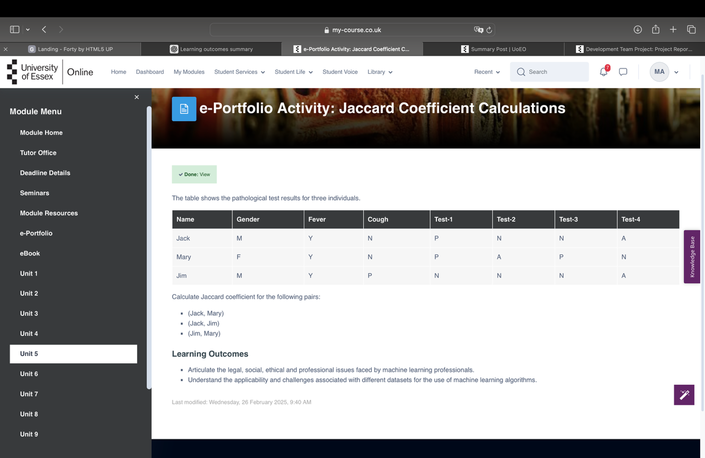

Unit 6: Clustering with Python

Development Team Project:

For the Project Report attach Unit 6 Team Project group 2 pdf that I sent you

For Peer Review (Individual) attach peer evaluation Mariam_ group 2 pdf that I sent you

For Download Project Python Code keep it the same as my friend

And ignore weekly meeting note – not required

Unit 7: Introducation to Artificial Neural Networks

Eportfolio Activity:

Check my friend question if it’s the same as my below question attach the same answers if not solve it and attach the correct answers

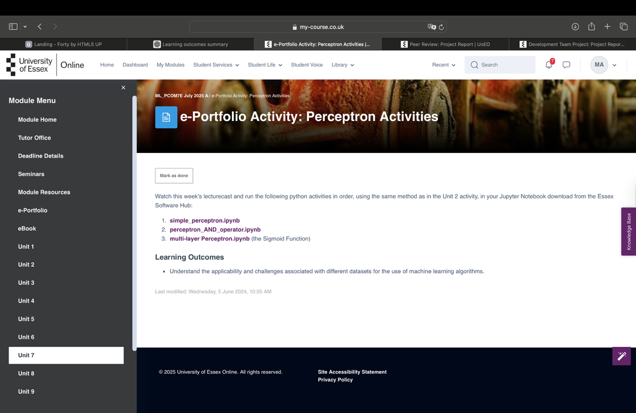

Unit 8: Training and Artificial Neural Network

Collaborative Discussion 2:

Initial Post:

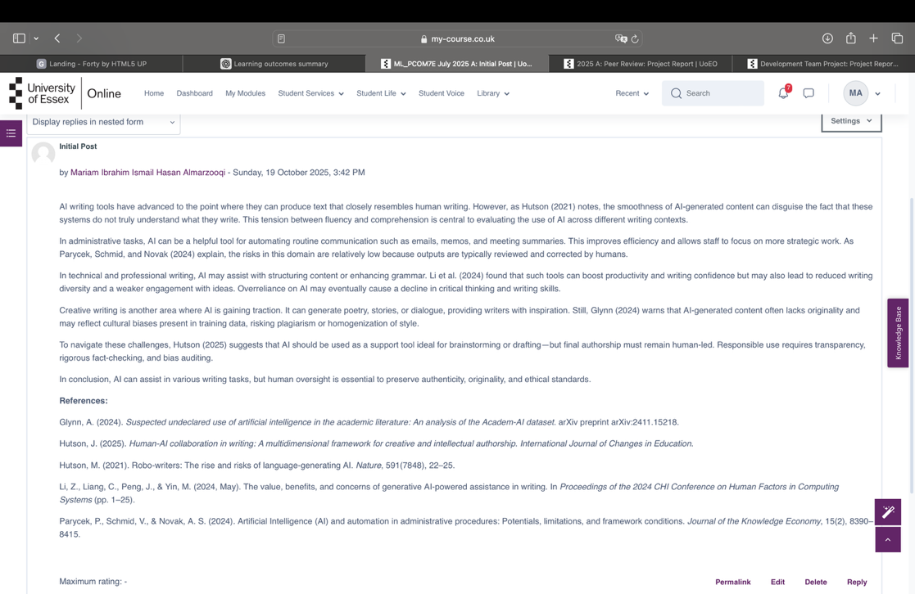

Eportfolio Activity:

Check if the screenshot question is the same as my friend attach my friend answer to my website

Unit 9: Introduction to Convolution Neural Networks

Collaborative Discussion 2:

Peer Response to Abdulla Almessabi

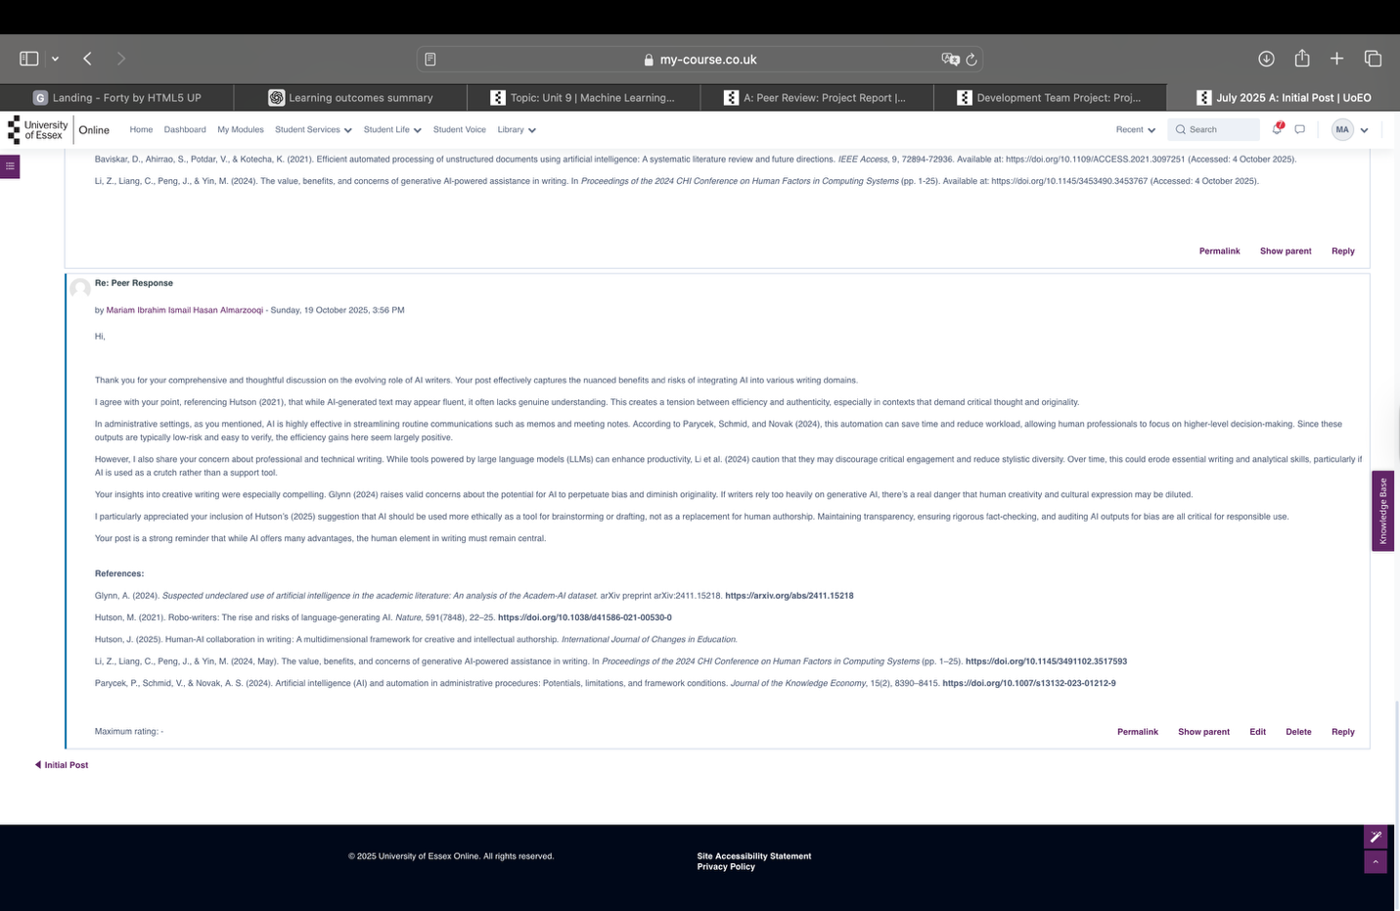

Peer Response to Ali Alhammadi

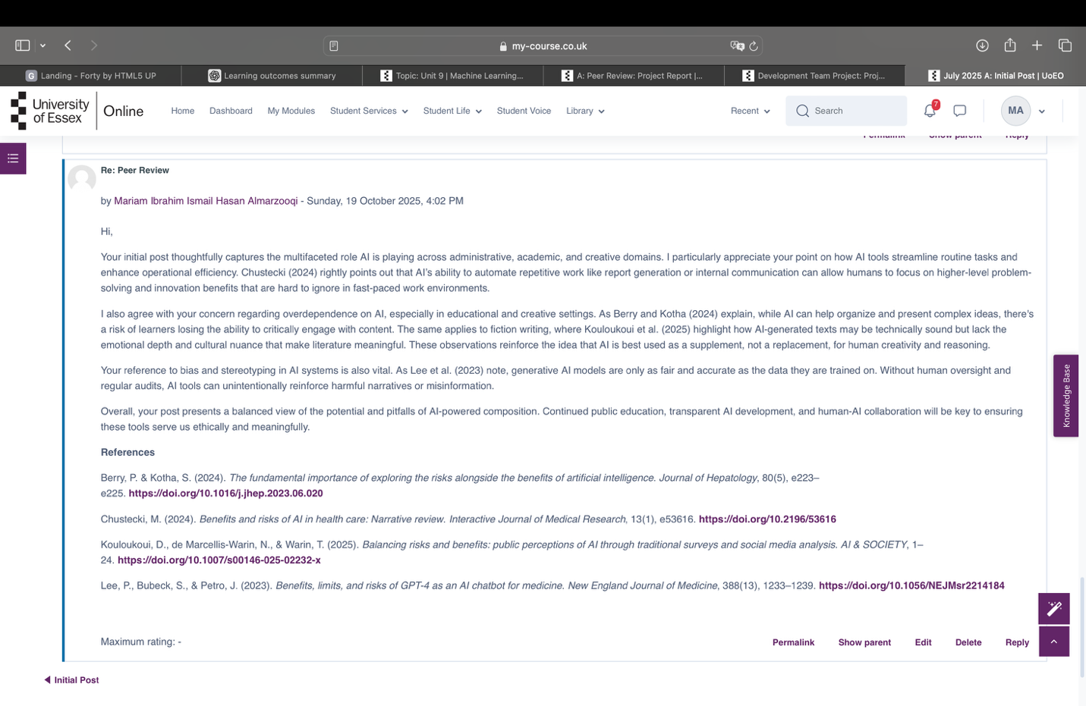

Peer Response From Colleagues

Eportfolio Activity:

Check my friend question and answer if it’s the same attach her answer if not solve it and attach it

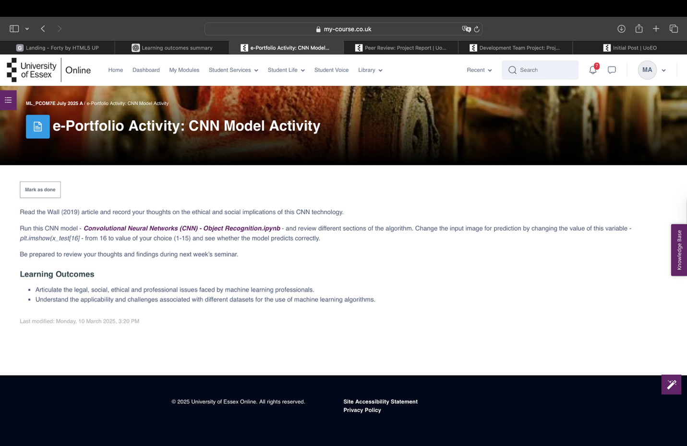

Unit 10: Natural Language Processing

Collaborative Discussion 2:

Summary post:

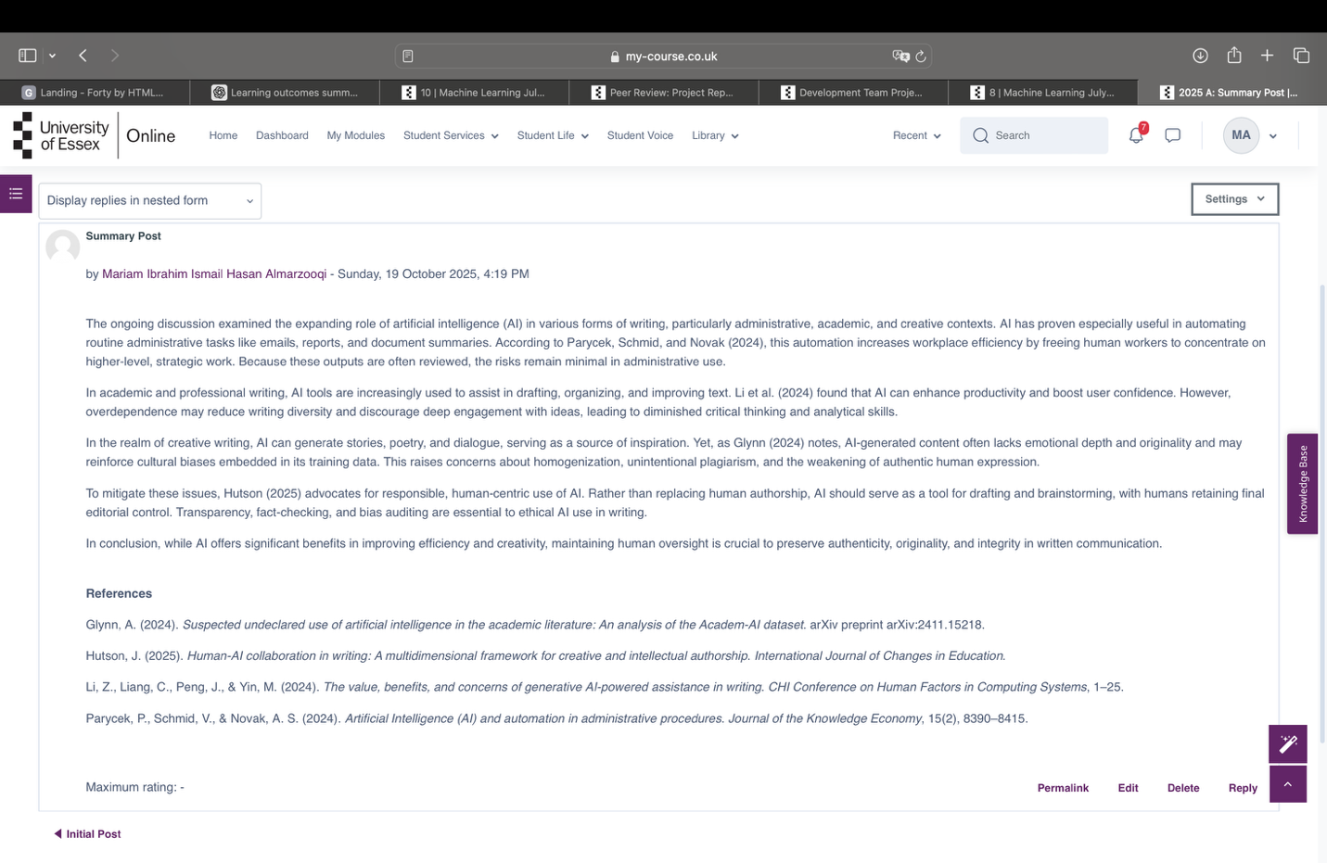

Unit 11: Model Selection and Evaluation

Eportfolio Activity:

Check my friend question and answers if it’s the same attach the same answers if its different solve the below

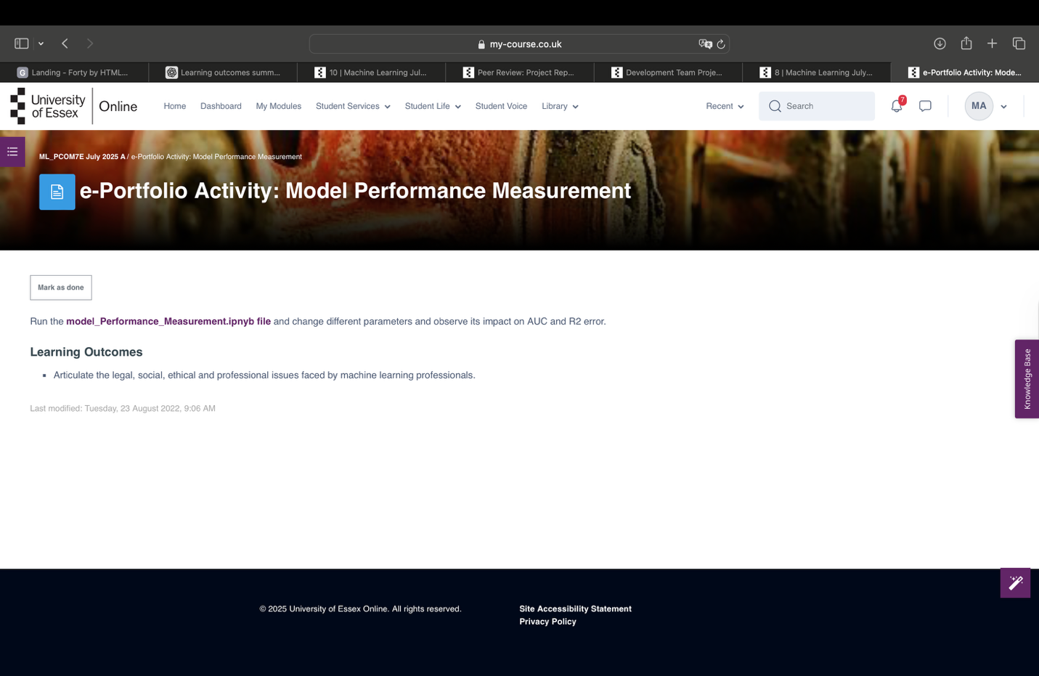

Individual Presentation:

Attach CIFAR_Presentation.pdf that I sent you

Unit 12: Industry 4.0 and machine learning

End of Module Assignment:

When you finish the writing eportfolio report attach it here

Professional Skilla Matrix and Action Plan (PDP)

Attach the same as my friend